

**A New Heart for a Changing Payments System**

Speech given by

Minouche Shafik, Deputy Governor, Markets & Banking

Bank of England 27 January 2016

I would like to thank Andrew Hauser, Chris Salmon, Ankita Mehta, Grellan McGrath, Toby Davies and John Jackson for their comments.

# The Bank at the heart of the payment system

Sometime around 1770, just a few yards from where we are sitting tonight, two of the commercial banks’ so-called ‘Walk Clerks’ congregated at the Five Bells Tavern for lunch, weary after a morning spent visiting each of their competitors in the City of London.1 They reflected disconsolately on their increasingly impossible task of exchanging ever-rising numbers of paper cheques at each individual bank and settling ever-larger outstanding balances. The idea occurred to one of them that they might encourage all of their colleagues – for each bank had such Clerks – to join them for lunch at the Five Bells every day, where instead of their tiring morning tours they could carry out a much speedier, more reliable exchange of cheques. Thus a clearing system for the City of London was born, from which many of the UK’s modern payment systems descend.

From the start, the Bank of England has stood at the very heart of this system. Historically, banks had settled their net obligations to one another in coin. But coins were an inefficient settlement asset, being difficult and risky to transport. So banks increasingly looked to the Bank of England to help settle the mutual obligations, using Bank of England bank notes as the settlement asset. Later, clearing began to take place directly across accounts held at the Bank. The Bank’s Archive still holds copies of the ledgers recording the balances on those accounts – Figure 1 shows example pages from the late 1870s.2

A lot has changed in the past 250 years. Pubs, thankfully, no longer form the hub of the clearing system! Paper – whether in the form of elegantly-scribed ledgers, or IOUs – is also almost wholly extinct in interbank clearing, with 98% of payments by value now made electronically, and only 2% using notes, coins and cheques. The pace of development of alternative methods of payment for households and companies has also accelerated dramatically, driven by new and innovative technology. It is hard to imagine what one of those Walk Clerks from the 1770s would make of the range of cashless, real-time, mobile payments options available in the shops, restaurants and stations in and around Lombard Street today.

Yet, amidst all this change, some things remain the same.

The Bank of England still lies at the heart of the sterling interbank payment system and banks still value the finality provided by settlement in risk-free central bank money. The role of the Bank of England as settlement agent originally arose from its unique ability to create sterling. But the fact that it retains this role after so long a time also reflects the trust placed in it by financial market participants and the wider public.

Paper ledgers are long gone at the Bank of England. But in their place lies the Real Time Gross Settlement system (RTGS), across which all payments between banks are settled.3 The amounts involved are immense. On an average day, RTGS settles around £500 billion between banks; that is almost a third of the UK’s annual GDP every single day. In turn, those payments back nearly every other payment that matters to

1 See Matthews (1921)

2 *Cashier’s Department: Drawing Office Customer Account Ledger*. The Bank of England Archive, Reference No. C98/4172

3 Either directly in the case of high-value payments made via CHAPS, or indirectly after netting in the case of retail payments made via the various private sector schemes.

all of us on a daily basis – from salaries to company invoices, from car purchases to coffee sales, from pensions to investment flows. So it is no exaggeration to say that RTGS is the beating heart of the UK payment system.

Indeed, RTGS is more critical to the UK economy than even these statistics suggest. By hosting the reserves accounts of the banking system, RTGS provides the mechanism through which the Bank provides liquidity for financial stability purposes and implements Monetary Policy Committee (MPC) decisions on Bank Rate. So it is intimately linked to the delivery of every aspect of the Bank’s mission.

The Bank’s primary motivation in the provision of a high value payment system has always been to promote stability and resilience. From today’s vantage point, it is easy to forget how revolutionary the introduction of RTGS was back in 1996. Before RTGS, all interbank payments were subject to some element of settlement risk – the risk that a bank would fail between the time it promised to make a payment, and the time it delivered on that promise. By allowing banks to settle high value transactions between each other, electronically, in real time, RTGS eliminated settlement risk on the largest payments flows – the ones most likely to threaten financial stability by bringing down the system if they failed.

But that is not the only innovation that RTGS has delivered over the years. As the financial system has evolved, RTGS has been regularly updated, introducing a raft of new functions and risk mitigants to respond to changing demands. Today, we are announcing that the Bank has completed, or agreed steps that will complete, all the actions in response to the Deloitte report4 published in March last year following the RTGS outage in October 2014.

Looking forward, as we celebrate RTGS’ twentieth birthday during 2016, it is again time to ask fundamental questions about the shape of the Bank’s settlement operations. The way payments are made has changed dramatically in recent years, reflecting changes in the needs of households and companies, changes in technology, and an evolving regulatory landscape. The range of payment providers is growing rapidly.

Given the implications of these changes for the Bank’s mission and for users, businesses and regulators, it is important that the Bank consider how RTGS will need to evolve to meet and shape payments trends in the coming decades. That is why we are today announcing our plan to design a blueprint for a new heart that can support the future demands placed on the UK’s high-value sterling settlement system.

In my remaining remarks tonight I want to do three things. First, set out some of the key drivers of change. Second, explain some of the strategic questions we want to ask on the future role of RTGS. And, third, set out how we will go about developing a blueprint for a new high value payments system.

4 The Deloitte Report on the October 2014 RTGS outage can be found here: [http://www.bankofengland.co.uk/publications/Documents/news/2015/rtgsdeloitte.pdf.](http://www.bankofengland.co.uk/publications/Documents/news/2015/rtgsdeloitte.pdf) An update on the completion of the recommendations of the Deloitte Report can be found here: <http://www.bankofengland.co.uk/markets/Documents/paymentsystems/deliotteactions.pdf>

# Evolution in the payments landscape

Much has changed in the UK payments landscape in the past twenty years. In particular, I want to highlight two linked drivers of change as being important in shaping the future demands placed on the Bank’s provision of real-time settlement: the changing regulatory environment and developments in payments technologies.

Some of the most important recent changes in the payment landscape have been catalysed by regulatory intervention, for example the development of the Faster Payments Scheme (FPS).5 In the past, regulatory intervention in retail payments has been targeted, addressing specific problems as and when they have emerged. Going forward however, the Payments Systems Regulator (PSR) which launched in 2015 is likely to create a new dynamic by stimulating a greater focus on competition and innovation in payment systems.

Alongside this new regulatory focus, the pace of technological change in payments has picked up sharply. Recent years have seen huge growth in demand for payments services that can be accessed in real time, at any time (‘24x7x365’), in a wide variety of locations through mobile phones and tablets. The software on these devices also makes growing use of so-called Application Programming Interfaces or ‘APIs’ which allow the seamless integration of payment into websites, and offer new ways to utilise payments data to improve services to customers. The ‘electronification’ of payments and rise of mobile banking has enabled

non-banks to deliver services using existing payments infrastructure and made it possible for challenger banks to grow without having to build an extensive branch network.

The emergence of various forms of Distributed Ledger Technology (DLT) poses much more profound challenges because it enables verification of payments to be decentralised, removing the need for a trusted third party. It may reshape the mechanisms for making secured payments: instead of settlement occurring across the books of a single central authority (such as a central bank, clearing house or custodian), strong cryptographic and verification algorithms allow everyone in a DLT network to have a copy of the ledger, and give distributed authority for managing and updating that ledger to a much wider group of agents. The Bank is undertaking work to understand the implications of new digital or e-monies and new methods of payments and financial intermediation as part of the One Bank Research initiative6.

Machine learning also promises to transform financial services and widen the potential players in payments. Banks will increasingly be able to automate interaction with customers. As ever more data is analysed and algorithms that ‘learn’ replace rules-based programming, a number of areas such as credit assessment, risk management, fraud detection and product personalisation will increasingly rely on technology. Many banks are already embracing these changes, but many non-bank players with ready-made access to a wide range of customers and their data are well positioned to compete.

5 The Faster Payments Scheme launched in May 2008 and allows payments to be made 24 hours a day, seven days a week. 6 Further information on the One Bank Research initiative can be found here: <http://www.bankofengland.co.uk/research/Pages/onebank/agenda.aspx>

Alongside the potential opportunities offered by changes in technology, there are also potential risks. For example, the demand for real-time retail payments can make it harder to implement effective defences against money laundering, terrorist financing, identity theft or other forms of fraud. More connected,

IT-intensive networks provide more channels for cyber attackers to target and greater risks of contagion. And rapid growth of non-bank payment providers could have profound implications for the business models of banks, challenging their revenue streams, altering the economics of credit provision and changing the risks to financial stability. New payments technologies also pose practical challenges, such as ensuring they interface effectively with legacy IT systems in banks and payments infrastructure.

What does all of this mean for the future of RTGS? Because of the changing context I have described, the Bank of England has decided the scope of the blueprint should be broad. We need to understand these trends, whilst recognising that there is considerable room for debate about the impact of the current wave of technological innovation. We need to think about to whom we give access to the advantages of central bank money with its unique qualities of finality of settlement. Trying to predict the future is a risky business, but when we make decisions about investment in systems that will last for a decade or more, they need to enable the kinds of changes that users will demand. So we need to make sure that we have “optionality” built in so that we can cope with different states of the world.

We may conclude that the right way forward is a like-for-like replacement of the current RTGS using more modern technology. Or we may decide that more radical change is needed to meet the needs of the UK’s future financial system. We genuinely do not have preconceptions on this question – and will want to consult closely with all of you, and a wide audience beyond this room, on the benefits, costs and risks of alternative options.

# A blueprint for RTGS and the Bank’s settlement infrastructure

Having set out the context in which we will develop the blueprint, I want to say a few words about how it will be structured.

The blueprint will seek to answer four overarching questions. First, what should the Bank’s policy **objectives**

be in the delivery of sterling settlement in central bank money? Second, what **functions** should the

UK High Value Payments System have? Third, who should be able to **access** it, and how? And, fourth, what should the **role of the Bank of England** be in the delivery of that service?

Let me elaborate a little on each – starting with policy **objectives**.

The mission of the Bank of England is to promote the good of the people of the United Kingdom by maintaining monetary and financial stability. The Bank promotes stability in sterling payments in four ways: through its operation of RTGS; through the provision of liquidity insurance to the banking system; through its supervision of CHAPS, the other recognised payment systems, CREST and Central Counterparties; and through the prudential supervision of banks by the PRA.

As discussed at the Open Forum in November, where there are coordination or market failures the Bank can and has used its unique position to shape financial markets for the public good.7 The Bank of England has a long history of using its convening powers to solve collective action problems, not least the introduction of RTGS itself in the mid-1990s. Around the same time, the Bank also had to step in to take over the design and construction of the UK’s securities settlement infrastructure CREST, after the collapse of the

Stock Exchange’s TAURUS project. We were strong supporters of the Continuous Linked Settlement8 initiative, which since 2002 has played a major role in reducing settlement risk in foreign exchange transactions. More recently, the Bank has taken opportunities to modernise and innovate in response to the changing external environment. For example, the Bank has overhauled its framework for liquidity provision and is preparing to introduce polymer banknotes.

In sum, while our primary concern will always be stability, we recognise that, given the importance of the Bank’s settlement operations to the overall system, our decisions will not only reflect but also shape the future payments landscape.

The second issue is the desired level of **functionality**.

RTGS has evolved considerably over its twenty years. Recent examples from a long list include: the introduction of a liquidity savings mechanism in 2013, reducing the risk that banks will be unable to settle payments due to liquidity shortfalls9; the introduction of ‘pre funding’ in 2015, ensuring that all net exposures in retail schemes that settle in RTGS are backed by central bank money; and the planned extension in June this year of RTGS opening hours.10

Against this backdrop, we will ask what further changes might be required from a new platform, as the needs of the wider payments universe develop. There are many potential questions. What are the implications of growing demand for a ‘24x7x365’ model of retail payments? What enhancements to cyber security will be required in future years? Have we pitched the balance between minimising settlement, liquidity and operational risk in the right place? What will be the impact of relatively nascent technologies such as the distributed ledger? Should RTGS adopt the latest messaging standards, not least to promote their use more broadly within the UK’s financial system? Are stakeholders comfortable that the right types of payments are being made in real-time across RTGS?

We cannot answer all of these questions in a year – so an early priority, with your help, will be to identify the most pertinent areas to focus on.

The third theme of the blueprint is **access**.

7 The Open Forum session on the role of central banks in financial markets can be watched here: <https://www.youtube.com/watch?v=SJCilk1XdZ0&index=12&list=PLslyOrpjJ0z38nDN-8fCiDKpCDpKMKZc9>

8 Further information on the Continuous Linked Settlement system can be found here: <http://www.cls-group.com/Pages/default.aspx>

9 See Davey and Gray (2014)

10 Further information on the planned extension of RTGS opening hours can be found here: <http://www.bankofengland.co.uk/markets/Pages/paymentsystem/extending.aspx>

Access to a settlement account in RTGS is currently open to any bank, building society, broker-dealer or CCP that holds a Bank of England reserves account or any financial market infrastructure whose participation is judged by the Bank to be enhancing to financial stability.11 Compared with similar systems in other major jurisdictions, access to RTGS is relatively highly ‘tiered’: almost 90% of the roughly 400 licensed banks and smaller banks choose to settle indirectly through a correspondent bank. In order to enhance financial stability by reducing dependencies between large banks and smaller banks, the Bank of England and CHAPS Co undertook a de-tiering initiative which has resulted in a greater number of banks having direct access to RTGS.

There is a question about whether we should go further and encourage or require a much larger number of banks to become direct members of major UK payment systems and have an RTGS settlement account, in order to spread the settlement risk benefits of RTGS more widely. The emergence of a new breed of

non-bank payments service providers, regulated by the FCA, has extended that debate further, since it is currently a requirement of a number of retail systems – in particular FPS and Bacs – that direct participants should have a settlement account at the Bank.

Major changes to the access arrangements to settlement accounts raise both policy and practical questions for the Bank – and could have implications for market participants and fellow regulators too – so it is right that they should be considered as part of the development of a broader blueprint. Targeted extensions in access could bring benefits in terms of innovation. But we need to think through the implications for stability, market structure and costs.

The final theme of the blueprint is the **role of the Bank**.

The Bank developed the RTGS infrastructure itself, and is responsible for the maintenance and development of all elements of its hardware and software. The Bank is also responsible for the day-to-day operation of RTGS, although these running costs are in turn charged out to its users on a full cost recovery basis. The rules and procedures of the various payments systems that settle in RTGS – CHAPS, Bacs, FPS, LINK, Cheque & Credit, and Visa Europe – are maintained by their respective private sector members, though there is close co-operation between the schemes and the Bank’s operational team. The recognised payments schemes are themselves supervised by the Financial Markets Infrastructure Directorate of the Bank.

We will want to examine the Bank’s role in delivering payments and settlement services, looking closely at how the United Kingdom compares to elsewhere around the world and the international guidance on risk standards set out in the Principles for Financial Market Infrastructure. The Bank’s experience, particularly during the financial crisis, has been that having direct operational control over RTGS has paid substantial dividends in terms of the delivery of its mission, so I think it is fair to say we start with a certain bias in that

11 The Bank stands ready to act as a settlement agent for payment systems recognised under the Banking Act or whose access to settlement in central bank money is otherwise judged by the Bank to be likely to reduce the risk of widespread disruption. There are currently 6 payment schemes for which the Bank acts as settlement agent (as well as the CREST securities settlement system) and there are around 40 settlement account holders in RTGS.

regard. But the appropriate model for IT development, service governance and risk management depends quite heavily on the chosen way forward for the RTGS infrastructure.

In light of the emerging results of the blueprint, the Bank’s supervisory function will review whether any changes are necessary to the supervisory model for the high value sterling payments system.

# A blueprint with buy-in

The agenda I have set out today is an ambitious one, with important implications both for the many institutions and infrastructures that interface with the system today and for those that might do so in the future. Our aim is that by the end of 2016 we will have agreed a blueprint for high-value sterling settlement in the years ahead, with technological development of that blueprint beginning in 2017.

To reach that deadline, there is a great deal to do – and we cannot do it on our own. In the first part of 2016 we will be seeking input from a wide range of stakeholders, both in the industry and outside it, to help define the questions and ensure we have identified the right options. We will be looking overseas to learn what we can from similar exercises conducted in other jurisdictions. Later in the year we expect to consult formally and in public on a focussed set of alternative ways forward. Throughout that process, we will need your help and guidance – to ensure we understand how the future payments landscape is likely to develop, to identify the needs of market participants, and to provide practical guidance and assistance. At a time when firms face many competing initiatives, we understand the importance of minimising uncertainty, and providing rigorous costings for what we propose.

Throughout the year and beyond, we will work closely with the industry, our supervisory colleagues at the Bank of England, the Payment Systems Regulator and its Payments Strategy Forum, HM Treasury and the Financial Conduct Authority to develop a blueprint with the broadest possible buy-in.

# Conclusions

In the pursuit of financial stability, the importance of resilience can hardly be overstated: a persistent disruption to people’s ability to make and receive payments would cause great damage to the UK economy, so Parliament and others rightly hold the Bank and the wider financial community to the highest standards of stability. It is sometimes claimed that this relentless focus on stability makes central banks the enemies of innovation, and defenders of the status quo.

I believe that is a fallacy. Innovation and stability can go hand in hand, as some of the history of payment systems has shown. The innovation of meeting in the Five Bells every lunchtime reduced the risk that Walk Clerks would lose track of their notes and coins while trooping from one bank to another around the streets of the City of London. The move to a central ledger at the Bank of England removed the need for notes and coins to be exchanged between banks at all. The advent of RTGS removed the risk that a bank

would fail before it made a promised payment. More recent reforms have reduced liquidity risk in RTGS and

extended access and hours of service. Our challenge will be to navigate a path that redesigns RTGS in such a way that its resilience is further enhanced, while at the same time enabling innovation for the public good.

Thank you.

**Figure 1**: Customer account ledger from 1878, from the former Bank of England Cashier’s Department Drawing Office, now held in the Bank of England’s Archive collection.

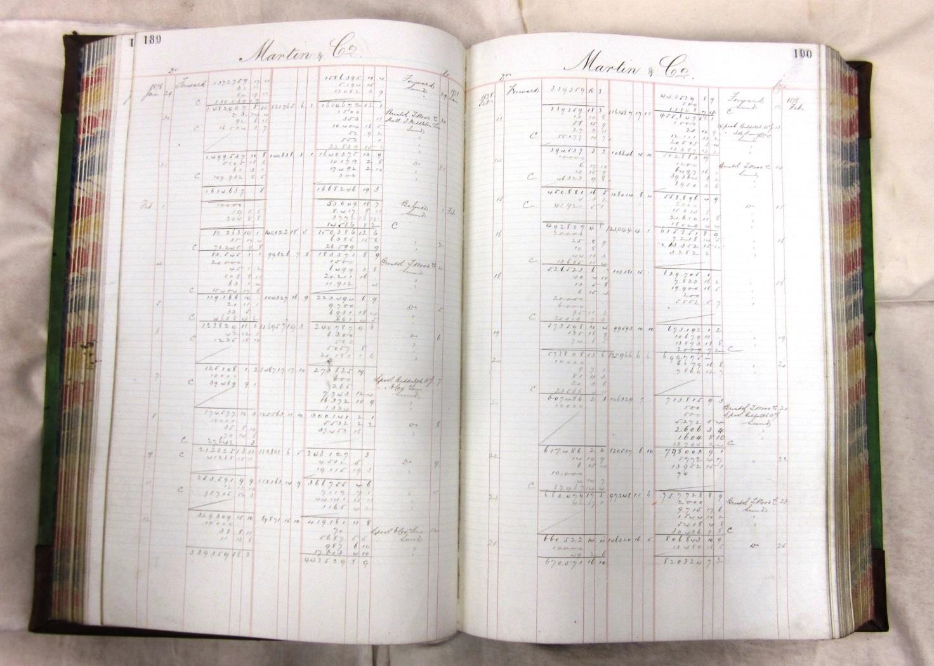

# References

Bank of England (1989), ‘Challenges facing the sterling wholesale payment systems’, *Bank of England Quarterly Bulletin*, August, pages 401-06.

Bank of England (1994), ‘The development of a UK real-time gross settlement system’. *Bank of England Quarterly Bulletin*, May, pages 163-68.

Davey, N and Gray, D (2014), ‘How has the Liquidity Saving Mechanism reduced banks’ intraday liquidity costs in CHAPS?’ *Bank of England Quarterly Bulletin,* Vol. 54, No. 2, pages 180-186, 2014 Q2, available at <http://www.bankofengland.co.uk/publications/Documents/quarterlybulletin/2014/qb14q207.pdf>

Dent, A and Dison, W (2012), ‘The Bank of England’s Real-Time Gross Settlement infrastructure’, *Bank of England Quarterly Bulletin*, Vol. 52 No. 3, pages 234-244, 2012 Q3, available at <http://www.bankofengland.co.uk/publications/Documents/quarterlybulletin/qb1203.pdf>

Matthews, P (1921), ‘The Bankers’ Clearing House: what it is and what it does’, Sir I. Pitman & Sons limited.

Norman, B, Shaw, R and Speight, G (2011), ‘The history of interbank settlement arrangements: exploring central banks’ role in the payment system’, *Bank of England Working Paper No. 412.*